Dear Parents/Guardians

COVID-19
We just wanted to thank everyone for their understanding during our precautionary measures that we put in place during a week when a high number of children had a continuous cough and some with high temperatures. We followed the guidance provided to us by the Government and the NHS and thankfully all tests came back negative for COVID-19 and we did not have to close.
We will continue to follow up to date guidance and will keep everyone updated as things change. We kindly ask that if your child does have a continuous cough and/or a high temperature to not send them into pre-school until a PCR test has been carried out and a negative result has been provided, in order to protect all children and staff.
Wellies, waterproofs and spare clothes
Just a reminder that here at Pre-school we will go out in all weathers. Wellies are a must to ensure the children have spare shoes to change into after being outside. It is also advisable to send waterproof clothing that the children can wear in the garden.
Please send in at least two full sets of clothing, including socks and pants so the children have spares to change in to when they get wet or have accidents.
All spare clothes and wellies will be returned at the end of the summer term.
Labelling
Please could we remind parents/ carers to label the children’s belongings including water bottles and snack pots. It would help the staff greatly if all items are labelled.
At times the children remove layers of clothing and place them down and there is sometimes confusion to whose clothing it is. It would be very helpful if you could please label clothing to help us identify the children’s clothing.
Name labels can be purchased from www.mynametags.com and by using school ID 57511 at checkout you can also help raise money for the Pre-school.
Carrier Bags
At times we can have lots of children requiring a spare change of clothes. We are kindly asking parents to send a spare carrier bag in each so we can place their child’s wet clothing in to send home to minimise dry spare clothing getting wet.
Pre-school Uniform
Here at the Pre-school we do have logo t-shirts and sweatshirts available to purchase in our school colour, purple.
Sweatshirts are £10 each
T-shirts are £5 each
Both the sweatshirts and t-shirts come in sizes 3-4yrs or 5-6yrs and can be ordered through ourselves. Just speak to a member of the team who will be happy to help.
Card payments
We have just purchased a card reader so that we will soon be able to take card payments on site.
Uniforms, invoices and other pre-school related payments will all be able to be paid via the card reader if you wish to do so.

P.E on Wednesday’s
With such a successful PE session on the last two Wednesday’s, we have decided to continue PE every Wednesday afternoon up until the end of term.
Please can you send your child with a PE kit on a Wednesday as part of the session we are practicing with the children getting themselves undressed and dressed in preparation for school.
School Leavers Party
We were hoping to invite parents into the pre-school for a party with the school leavers, however due to the extension of lockdown restrictions we are unable to do this this term.
However, we will be having a party in pre-school for the children on Wednesday 7th July. We are asking parent’s to send their child with a party lunch on this day. Please be mindful that we are still a nut and pineapple free setting so all food should not contain any of these products.
Little Monkey’s Studio photo session
We had such a great response from the photo’s that took place on the 21st May.
From the sales of the photos we received £89 commission which we plan to use to extend our book corner and create a more calming reading area. We shall share photos of the area once we have purchased the resources required.
Thank you all so much.
Fundraising for Pre-school
We are always looking at new ways to raise money to help us extend the children’s learning here at the Pre-school.
With lockdown restrictions, hopefully reducing we are looking at planning events for the very near future, however, we would love to hear your suggestions of how we can raise funds for the pre-school. We are also looking at creating fundraising packs so people can fundraise on our behalf.
- Wellie walk 11th September at Fosse Meadows (more information to follow- school leavers invited)
- Coffee morning- Week beginning 23rd August (day to be confirmed)
- Christmas fayre- Saturday 20th November 2021 at Ullesthorpe Village hall (More information to follow) If you know of anyone who would like a stall at the fayre, please ask them to email ullesthorpe@btconnect.com or contact one of the team.
Transition reports
The time has come for some of our children to move on to their next journey to school. We will be sending out transition reports and are kindly asking if you can return them with your comments as soon as possible so we can forward them on to the schools.
Toy and book donations still wanted.
We are wanting to expand our toy and book offering to the children based on their current interests and we are looking for donations of good quality toys around the themes of – Peppa pig, Police and fire, Doctors and nurses and tea sets. If you have any of those items that you would be willing to donate, we would be greatly thankful. Please drop the items off to the entrance in a bin bag where we can pop them in isolation jail for 72 hours.
Committee members wanted!
We are looking to recruit more members to join our committee. If you would like to find out more about becoming a committee member and what it entails, then please email ullesthorpe.ps@gmail.com.
Things to try at home
50 Things To Do Before You're Five | Welcome
50 Things To Do helps parents develop their home learning environment, suggesting a wide range of low-cost and no-cost local activities. The 50 Things approach improves early language and literacy, motor skills and resilience.
Dates for your diary
Pre-school closes for Summer break- Friday 9th July 2021
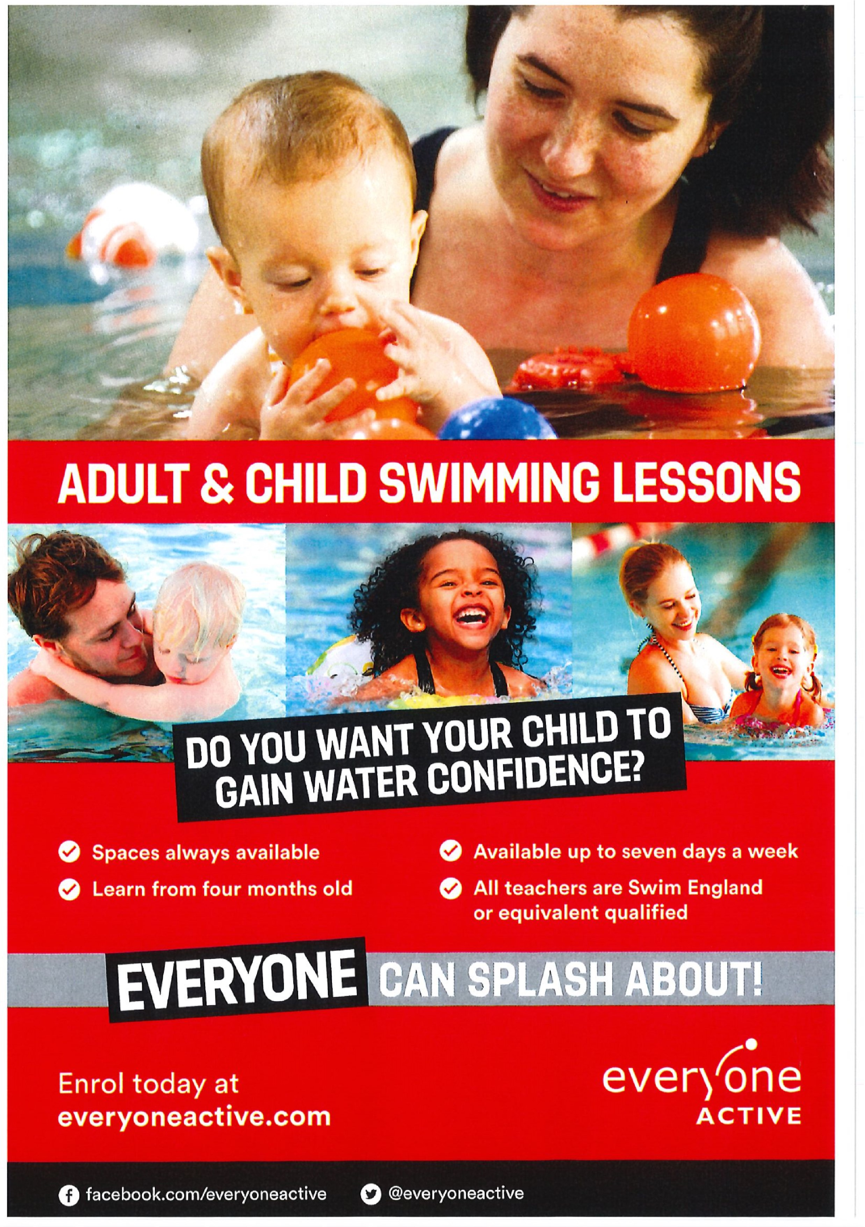
Pre-school reopens on Tuesday 31st August 2021

